Enrollment & Marketing for Christian Schools
Jim McKenzie, jimmckenzie@trsonline.org

“A leader’s primary role is to see and shape the future.”
– Mark Miller, VP for Organization Effectiveness, Chick-fil-a

What is Your Vision or Mission Statement?

Simon Sinek’s “The Golden Circle”

Mission-Minded vs. Vision-Driven
MISSION-MINDED | VISION-DRIVEN
- “What business are we in?”  - Answers: HOW  - Based on WHAT (success looks like)  - Organization-focused  - MEANS | - “What does success look like?”  - Answers: WHAT  - Based on WHY (a Christian school)  - Student-focused  - ENDS

MISSION-DRIVEN | VISION-DRIVEN
The mission of _____ School is to assist families in providing a Christ-centered education of high academic quality so the students may be prepared to take an active, vital place in the home, the church, the state and their future vocations by applying Christian principles in a Biblical manner. | Imagine your child …  Growing strong in character and academics,  Focused on God’s presence,  Led by caring teachers,  Being equipped to excel …  Imagine your child changing the world!  At ___ School, students become dream makers and world changers

Advantages of Vision-Driven:
- Academic Quality
- Enthusiastic Teachers
- Strong Christian Focus
- Modern Marketing
- Expanded Fund Development
- Resource Stewardship
Vision-Driven Teaching:
- I know as a teacher what the end goal is.
- I understand the metaphor.
- I have the creativity to teach towards the end I see fit.
- I am not teaching a curriculum.
- I am not teaching towards a test.
- I can fully embrace 21st century teaching methods.
Vision Bring Us Together!
“Business-Like” vs. “Ministry-minded”
value of program = changed student lives
FOUR BUILDING BLOCKS:

WHAT?

HOW?

WITH?
THROUGH?

Vision should always be defined in _____________________________ ______________________________.
5 Tips for Casting a Clear Vision:
- Make it memorable. (It’s a right-brained activity)
- Stay student-centric. (focus on student outcomes)
- Broadcast your differentiator. (think about what makes you unique)
- Promise for the long term. (keep it about the experience, not the product)
- Balance aspiration and realism. (make sure it’s believable for you & your staff)
A PARADIGM SHIFT IS CREATED:
From ________________________________ (mission) to ____________________________________ (vision).

3 Marketing Problems:
- Quality Control (the program issues)
- Customer Understanding (the people issues)
- Internet Age Marketing (the messaging issues)
3 Marketing Strategies:
- Retention (keep more current students)
- Close More Leads (enroll more prospective students)
- Capture More Leads (find more prospective students)

How Story Works (Don Miller) – Who is the hero of your story?

Why your school? List 10 primary reasons why families are reaching out to you.
1.
2.
3.
4.
5.
6.
7.
8.
9.
10.

Two Audiences for Christian Schools:
1.

2.

MESSAGING – THINKING THROUGH THE STORY YOU TELL
#1: Write for a specific audience.
Persona – a group of people who have common characteristics.
Christian schools usually have 4-5 personas. Do you know yours?
Write more like ____________________________________, less like ___________________________________.
Write more like a ____________________________, less like a ______________________________________.

#2: Stop thinking like a commodity.

COMMODITY | UNIQUE SERVICE
- Price & convenience  - Features are crucial  - We’re “one of many”  - Read about us! | - Value / connects to need  - Customer service is crucial  - We’re “one of a kind”  - Visit to know us!

#3: Write in terms of benefits, not features.
Feature: High Educational Standards
Benefit: My child will be well-prepared for college and career.
Feature: Strict “No Bullying” Policy
Benefit: My child will be safe, not abused.
Feature: Classroom Discipline
Benefit: My child will have a great learning experience because distractions will be minimized.

ENROLLMENT CLOSING – MOVING FAMILIES FROM INQUIRY TO ENROLLMENT
#1: Get parents to “darken the door.”
#2: Offer educational consultations, not tours.
#3: Parents meet with the Principal.
#4: Keep the action with you.
#5: Track everything!

“Selling is no longer about persuasion. Selling is about understanding your customer’s problems and solving them.”
---Neil Rackham, Spin Selling, 2004

SPIN SELLING:

C | CURRENT MARKETING STRATEGIES | R

How to grow your Christian School:
#1:

#2:

#3: Everything else.

WORD-OF-MOUTH MARKETING – CREATING A SALES FORCE BEYOND YOU
Why Word-of-Mouth Marketing?
- Easiest lead to close
- Sales force beyond you
- Least expensive lead
- Works year-round
- More like your most valuable families

Parent Satisfaction is the key to _______________________________ & _____________________________.

What do parents want?
Top Ten: ___________________________________________ & ____________________________________________
Bottom Ten: ________________________________________ & __________________________________________,
& ____________________________________________

50-60% of parent satisfaction is tied directly to the _________________________________________.

WOM Strategy: Identify and train your ___________________________________________________.

Hold a Reception (not a meeting!) and teach them:
- What to listen for.
- How to make a referral.
Then, remember to continue to:
- Keep it top-of-mind.
- Build a culture of referral in your school.

INTERNET MARKETING – MORE THAN JUST A PRETTY WEBSITE
Primary Goal: _____________________________________________________________!
Push “Call or Visit” not “Email Us.”
Use information as a “___________________________.”

Secondary Goal: __________________________________________________________.
Don’t assume they are sold on Christian education.

Tip #1: Don’t give them a reason to say no.
Tip #2: Don’t give them a reason to stay home.

A Tale of Two Sites:
- Prospective Families – the goal is generating leads
- Current Families – the goal is customer service

DIFFERENTIATION – FOCUS ON WHAT MAKES YOU DIFFERENT
What makes your school unique?

What are things your local public school can’t/don’t do well?

#1: Flanking vs. “Me Too” Branding
“Me Too” branding – copying what other schools do in an effort to remain competitive.
Flanking – creating programs that are different and hard to copy.
- Having a “difference” that is truly different.
- Having a difference that parents care about.

#2: Proactive Customer Service
Book: How to Get Your Competition Fired (without saying anything bad about them)
Examples:
- Communication
- Character Development
- Leadership Development
- Holidays / Patriotism
- Foreign Language
- Dual Credit

A TUITION & FINANCIAL AID PHILOSOPHY
Did Jesus’ ministry target based on economic status?
How much financial aid did your school award last year? $__________________________________

Problems with the Status Quo:
- For the full cost to educate a child, parents who can – don’t.
- Teacher salaries are unfairly low.
- “Lost cost leader” devalues you.
- Over emphasis on money = under emphasis on outcomes.
The gap in educational costs is often made up by donors making less than high-income parents who could afford to pay.
Do you really want your biggest financial aid decision to be made automatically with no input from you?

Which of these models best describes your current situation?
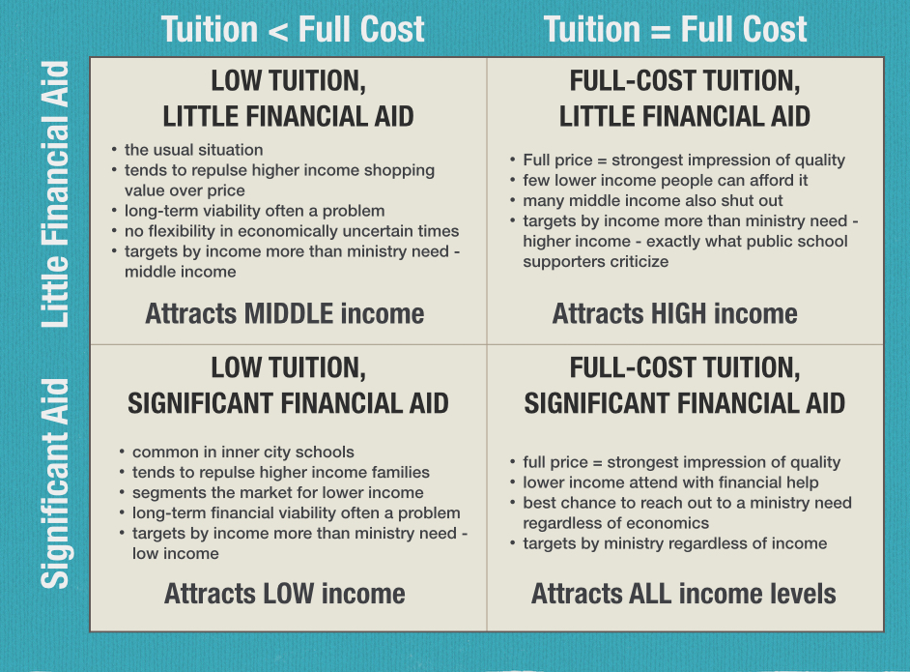

Financial Aid Quiz:
- Does financial aid need to be funded? __________
- Does financial aid need to be budgeted? _________
- Do we have to rigidly follow the budget? _________

RECOMMENDATIONS:
- Adopt a ______________________________________ model.

- All financial aid decisions made by ________________.

- Practically all financial aid is _________________________________________.
- “____________________________________________________________” go away.

ADVANTAGES OF THIS MODEL:
Financial: affluent people are now paying the full-cost to educate their child, which provides money for more lower income people to be served.
Development: shift from gap campaign (the annual deficit) to scholarship funding for families who could not otherwise afford our school.
Marketing: overcome the price question with the availability of much more aid. It’s the difference between “hanging up” and showing up.

Summer Enrollment Strategies:
What you can be doing right now
- Do Educational Consultations with prospective families.
- Call all non-enrolling families and “solve the problem.”
- Make follow-up calls correctly.
  - Don’t leave messages.
  - Have a specific reason to call (not Are you interested? Or Any questions?)
  - Work a sense of urgency. (escalating fees, financial aid deadlines, etc.)
- Ask your current families (by weekly email) to do Word-of-Mouth this summer.
- Send a “Buyer’s Remorse” letter when school begins.

Contact Information:
Jim McKenzie
352-514-3513 (cell)
jimmckenzie@trsonline.org

